Parent Permission Slip for

Woodward Public Library’s After Hours Teen Night

I _____________________ grant permission for my child _________________________

Parent/Guardian name Teen’s legal name

to participate in Woodward Public Library’s After Hours Teen Night __________(date). Doors will be open 7:00 – 7:15 p.m. and then will be locked until 9:00 p.m. No one may enter or leave between 7:15 and 9:00 p.m. unless there is an emergency.

Parents should be at the library to pick up their child no later than 9 p.m.

I also understand that the event is open to teens ages 13 – 18. Library staff will be on site all evening.

In case of emergency please contact:

Name _________________________________________________________________

Relationship ____________________________________________________________

Phone number __________________________________________________________

______________________________________________ ________________________

Parent or legal Guardian signature Date

If you would like this permission form to serve as a permission for all future library After Hours Teen Night events please sign below.

I _____________________ grant permission for my child ________________________ Parent/Guardian name Teen’s legal name

to participate in Woodward Public Library’s After Hours Teen Nights.

_____________________________________________ _______________________

Parent or Legal Guardian Signature Date

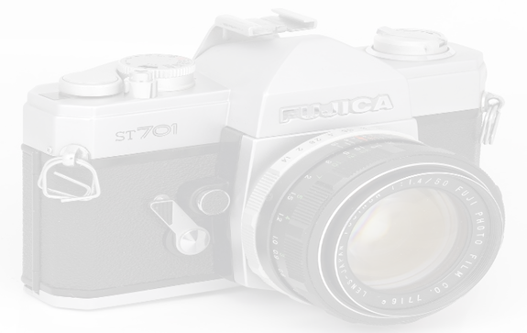

WOODWARD Public Library Photo/Video Image Release

**Photo Release Form for Adults**

I give permission to Woodward Public library to use photos/videos of myself to promote library services. I understand that the images may be used in print publication, library website and social media.

______________________ Yes ____________________No, I do not want my photo to be used

Name:______________________________________________________________________________

Phone Number: ______________________________________________________________________

Signature: _____________________________________________ Date________________________

**Photo Release Form for Minors**

I give permission to Woodward Public Library to use photos/videos of my child/ children to promote library services. I understand that the images may be used in print publication, library website and/or social media.

___________ Yes ___________No, I do not want my child’s/children’s photos to be used.

Parent/Guardian Name:_______________________________________________________________

Child’s/Children’s name(s):

____________________ ____________________ _______________________

____________________ ____________________ _______________________

Phone Number: ______________________________________________________________________

Parent/Guardian Signature : ______________________________________ Date_________________